**Tableau - Navigation**

## Menu Commands

On closing the getting started window we get the main interface with all the available Menu commands. They represent the entire set of features available in Tableau. Various sections of the menu are shown in the below diagram. Next we see some details of each menu.

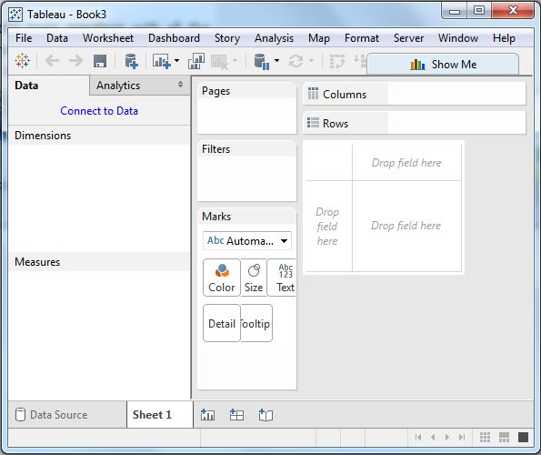

## File Menu

This Menu is used to create new Tableau workbook and open existing workbooks from both local system and Tableau server. The important features in this menu are:

* **Workbook Locale** to set the language to be used in the report.
* **Paste Sheets** to paste a sheet into the current workbook which is copied from another workbook.
* **Export Packaged Workbook option** is used to create a packaged workbook which will be shared with other users.

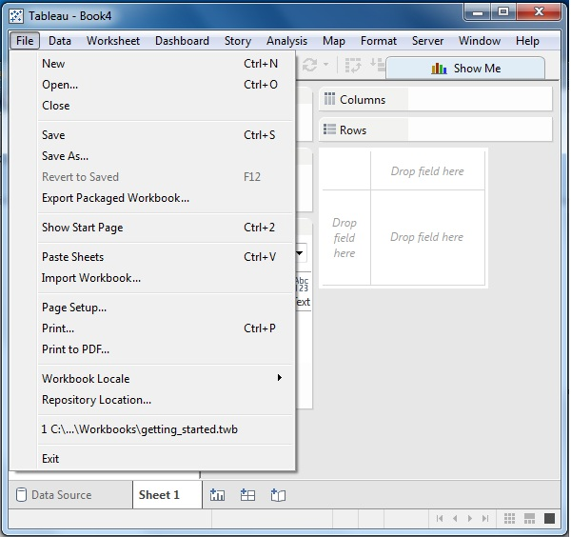

## Data Menu

This Menu is used to create new data source to fetch the data for analysis and visualization. It also allows you to replace or upgrade existing data source.

The important features in this menu are as follows:

* **New Data Source** to see all the types of connections available and choose from it.
* **Refresh All Extracts** to refresh the data form source.
* **Edit Relationships option** is used to define the fields in more than one data source for linking.

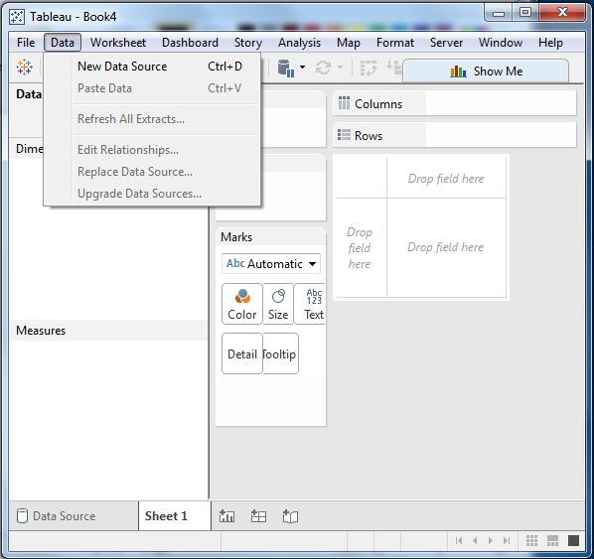

## Worksheet Menu

This Menu is used to create new worksheet along with various display features like showing the title and captions etc..

The important features in this menu are as follows:

* **Show summary** to see the summary of the data used in the worksheet like count etc..
* **Tooltip** to show the tooltip when hovering above various data fields.
* **Run Update option** is used to update the worksheet data or filters used.

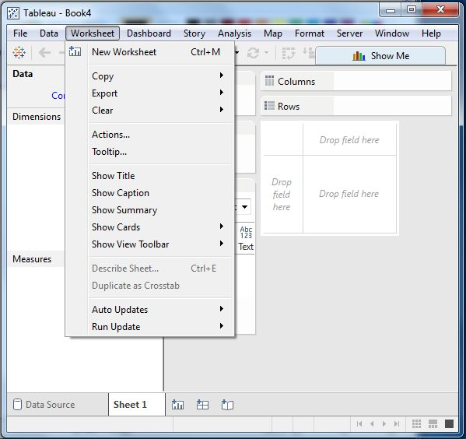

## Dashboard Menu

This Menu is used to create a new dashboard along with various display features like showing the title and exporting the image etc..

The important features in this menu are as follows:

* **Format** is used to set the layout in terms of colours and sections of the dashboard.
* **Actions** to link the dashboard sheets to external URLS or other sheets.
* **Export Image option** is used to export an image of the Dashboard.

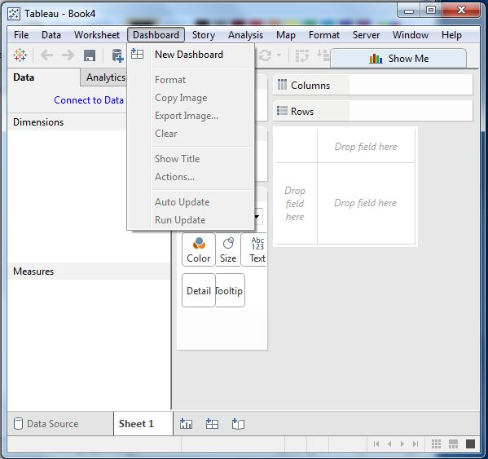

## Story Menu

This Menu is used to create a new story which has many sheets or dashboards with related data.

The important features in this menu are as follows:

* **Format** is used to set the layout in terms of colours and sections of the story.
* **Run Update** to update the story with latest data form source.
* **Export Image option** is used to export an image of the story.

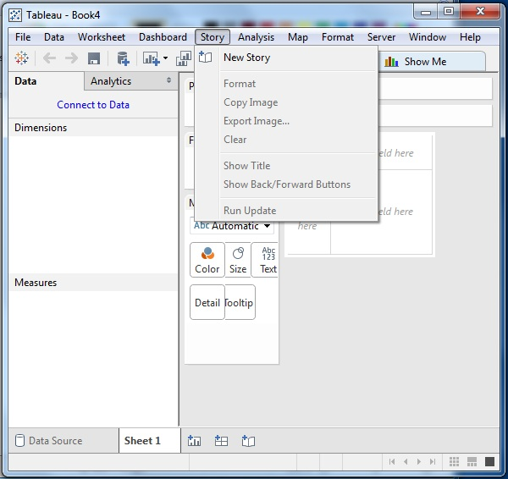

## Analysis Menu

This Menu is used for analyzing the data present in the sheet. Tableau provides many out of box features like calculating the percentage and doing a forecast etc..

The important features in this menu are as follows:

* **Forecast** to show a forecast based on available data.
* **Trend Lines** to show the trend line for s series of data.
* **Create calculated Field option** is used to create additional fields based on certain calculation on existing fields.

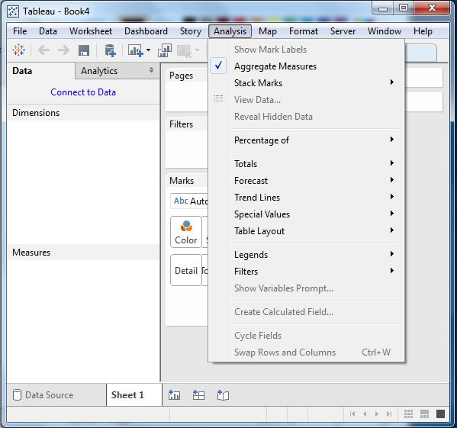

## Map Menu

This Menu is used for building map views in Tableau. You can assign geographic roles to fields in your data.

The important features in this menu are as follows:

* **Map Layers** to hide and show map layers, such as street names and country borders, and add data layers.
* **Geocoding** to create new geographic roles and assign them to the geographic fields in your data.

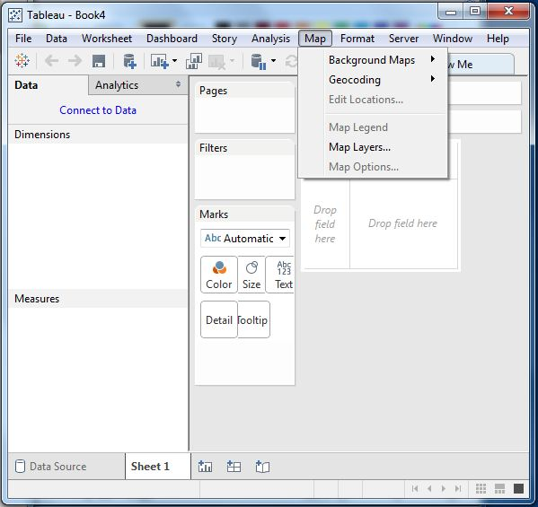

## Format Menu

This Menu is used for applying the various formatting options to enhance the look and feel of the dashboards created. It provides features like borders, colours, alignment of text etc..

The important features in this menu are as follows:

* **Borders** to apply borders to fields displayed in the report.
* **Title and caption** to assign a Title and caption to the reports.
* **Cell Size** to customize the size of the cells displaying the data.
* **Workbook Theme** to apply theme to the entire workbook.

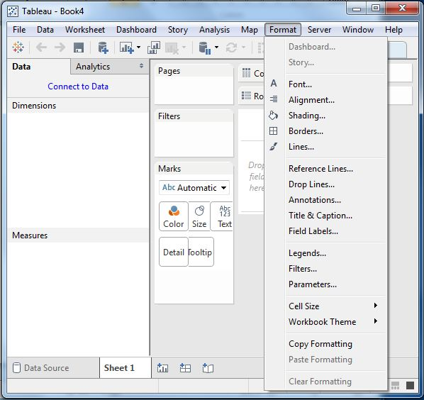

## Server Menu

Server Menu is used to login to the Tableau server if you have access and publish your results to be used by others. It is also used to access the workbooks published by others.

The important features in this menu are as follows:

* **Publish Workbook** to publish the workbook in the server to be used by others.
* **Publish Data source** to publish the source data used in the workbook.
* **Create User filters** to create filters on the worksheet to be applied by various users when the access the report.

